Experiment No: 4
Implement K-Nearest Neighbors (KNN) and evaluate model performance

1. Dataset Source
Iris Dataset
Source Link:
https://www.kaggle.com/datasets/uciml/iris

2. Dataset Description
The Iris dataset is a well-known dataset used for classification tasks. It contains measurements of iris flowers.
- Number of Instances: 150
- Number of Features: 4

🔹 Features:
- Sepal Length
- Sepal Width
- Petal Length
- Petal Width

🔹 Target Variable:
- Species
  - Setosa
  - Versicolor
  - Virginica

3. Mathematical Formulation of KNN
KNN works based on distance calculation.

🔹 Distance Formula (Euclidean Distance):
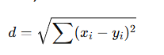

Where:
- xi, yi​= feature values

🔹 Working:
- Choose K neighbors
- Calculate distance
- Select nearest K points
- Assign majority class

4. Algorithm Limitations
- Slow for large datasets
- Sensitive to value of K
- Affected by irrelevant features
- Requires feature scaling

5. Methodology / Workflow
- Load dataset
- Data preprocessing
  - Feature scaling (important for KNN)
- Define X and y
- Train-test split
- Train KNN model
- Evaluate performance
- Tune K value

6. Performance Analysis
Evaluation Metrics:
- Accuracy
- Confusion Matrix
- Classification Report
Different K values affect performance:
- Small K → Overfitting
- Large K → Underfitting

7. Hyperparameter Tuning
- Main parameter: K (number of neighbors)
- Try values like: 3, 5, 7, 9
- Choose best accuracy
Code:
# STEP 1: IMPORT LIBRARIES
import numpy as np
import pandas as pd
import matplotlib.pyplot as plt
import seaborn as sns

from sklearn.datasets import load_iris
from sklearn.model_selection import train_test_split
from sklearn.preprocessing import StandardScaler
from sklearn.neighbors import KNeighborsClassifier
from sklearn.metrics import accuracy_score, confusion_matrix, classification_report

# STEP 2: LOAD DATASET
iris = load_iris()
X = iris.data
y = iris.target

# STEP 3: FEATURE SCALING (IMPORTANT)
scaler = StandardScaler()
X = scaler.fit_transform(X)

# STEP 4: TRAIN TEST SPLIT
X_train, X_test, y_train, y_test = train_test_split(
X, y, test_size=0.2, random_state=42
)

# STEP 5: TRAIN MODEL (K=5)
knn = KNeighborsClassifier(n_neighbors=5)
knn.fit(X_train, y_train)

y_pred = knn.predict(X_test)

# STEP 6: RESULTS
print("Accuracy:", accuracy_score(y_test, y_pred))
print("Confusion Matrix:\n", confusion_matrix(y_test, y_pred))
print("Classification Report:\n", classification_report(y_test, y_pred))

# STEP 7: CONFUSION MATRIX IMAGE
plt.figure(figsize=(5,4))
sns.heatmap(confusion_matrix(y_test, y_pred),
annot=True, fmt="d", cmap="Oranges")

plt.xlabel("Predicted")
plt.ylabel("Actual")
plt.title("Confusion Matrix - KNN")
plt.show()

# STEP 8: TRY DIFFERENT K VALUES
accuracies = []

for k in range(1, 11):
model = KNeighborsClassifier(n_neighbors=k)
model.fit(X_train, y_train)
pred = model.predict(X_test)
accuracies.append(accuracy_score(y_test, pred))

plt.plot(range(1,11), accuracies)
plt.xlabel("K Value")
plt.ylabel("Accuracy")
plt.title("K vs Accuracy")
plt.show()

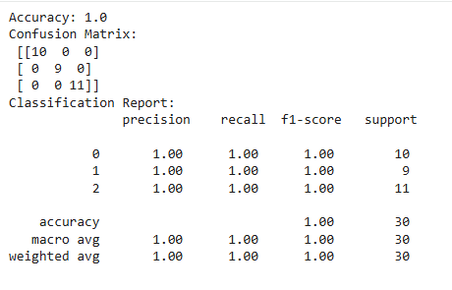
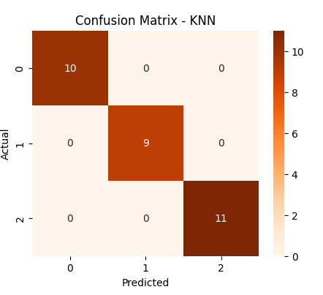
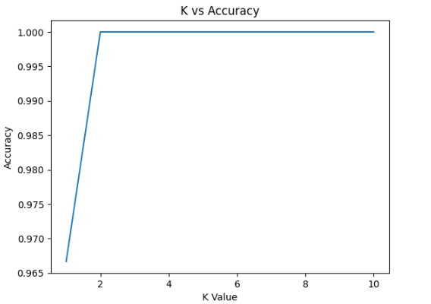
Conclusion:
KNN was successfully implemented for classification. The model performed well on the dataset, and accuracy depended on the choice of K. Proper selection of K improves model performance.

